CONCEPT ACADEMY
PHYSICS PROJECT

Project Title:
OHM’S LAW

Submitted By: Submitted To:
Students Name Teacher’s Name Mishra
Class:
Roll No:

School: KVS SGPGI Campus

CERTIFICATE

This is to certify that …………. of Class 12th , Roll No. ….. of ………………School has successfully completed the Physics project entitled “Ohm’s Law” under the guidance of the subject teacher. This project is submitted as part of the requirements for the Physics practical evaluation for the academic year 2025‑2026.

Teacher’s Signature: _______

Date: _______

ACKNOWLEDGEMENT

I would like to express my sincere gratitude to my Physics teacher for their valuable guidance and encouragement throughout the completion of this project. I also thank the staff and management of School, as well as my family and friends, for their constant support. This project has been a great learning experience and has enriched my understanding of electrical concepts.

CONTENTS

1. Aim
2. Theory
3. Apparatus Required
4. Circuit Diagram
5. Procedure
6. Observations
7. Graph
8. Result
9. Conclusion
10. Precautions

1. AIM
To verify Ohm’s Law by plotting a graph between potential difference (V) and current (I) across a resistor, and determine its resistance from the slope.

2. THEORY
Ohm’s Law states that the current (I) flowing through a conductor is directly proportional to the potential difference (V) across its ends, provided the temperature and other physical conditions remain constant.
Mathematically:
V = I × R
Where:
V = Voltage (Volts)
I = Current (Amperes)
R = Resistance (Ohms, Ω)
A graph of V vs. I should be a straight line passing through the origin.

3. APPARATUS REQUIRED
- Resistor (≈ 10 Ω)
- Ammeter (0–1 A)
- Voltmeter (0–5 V)
- Battery eliminator or dry cells
- Rheostat
- Connecting wires
- Key (switch)

4. CIRCUIT DIAGRAM
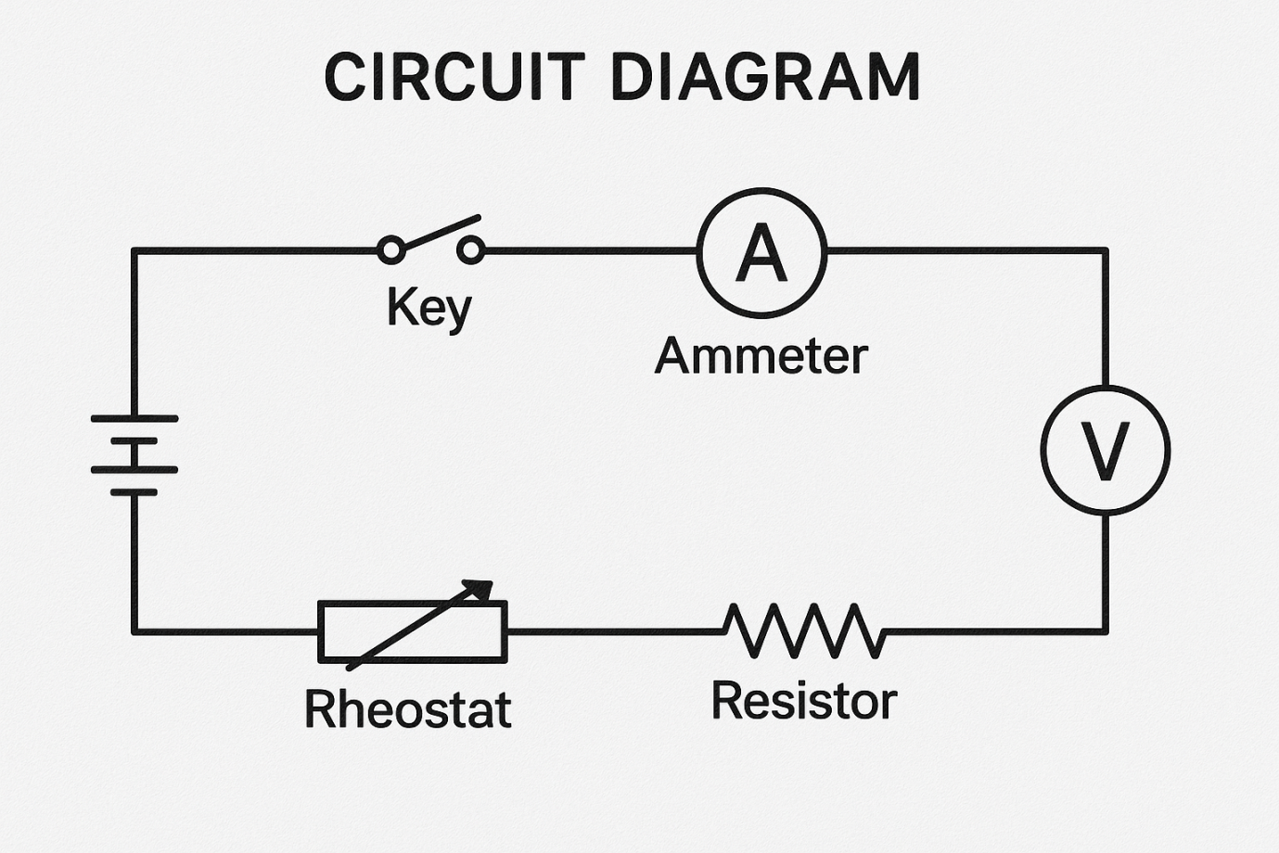

5. PROCEDURE
1. Set up the circuit as shown.
2. Close the key and adjust the rheostat to vary current.
3. Note the readings of the ammeter and voltmeter.
4. Repeat for at least five different current values.
5. Plot a graph with V on the Y‑axis and I on the X‑axis.
6. Determine the resistance from the slope (R = ΔV/ΔI).

6. OBSERVATION TABLE

S. No | Current I (A) | Voltage V (V)
1 | 0.1 | 1.0
2 | 0.2 | 2.0
3 | 0.3 | 3.0
4 | 0.4 | 4.0
5 | 0.5 | 5.0

7. GRAPH
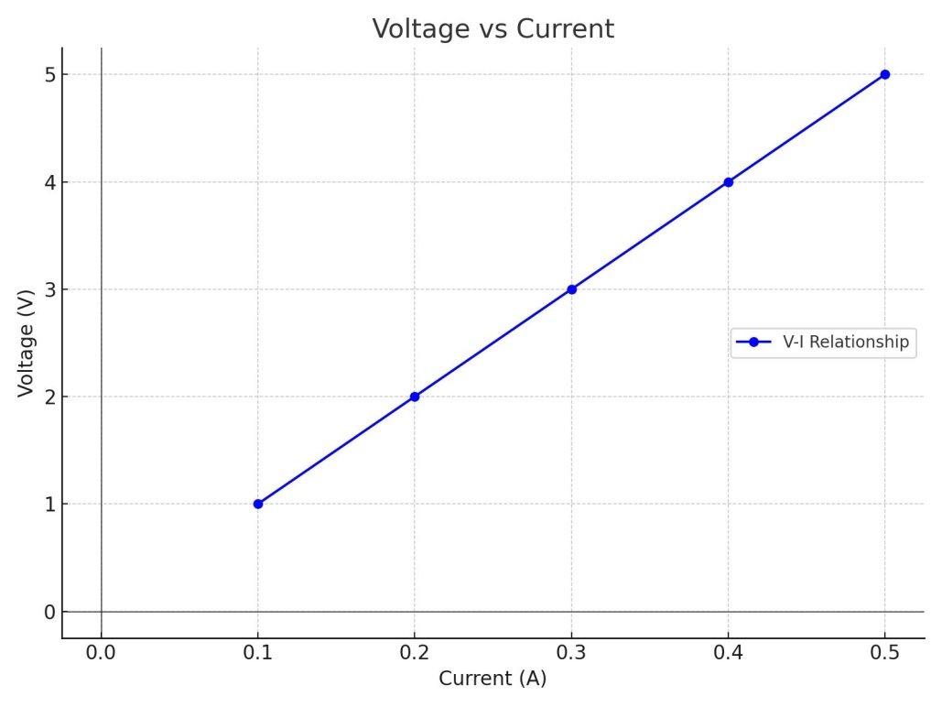

8. RESULT
– The graph is a straight line, verifying Ohm’s Law.
– The resistance calculated from the slope is approximately 10 Ω.

9. CONCLUSION
Ohm’s Law is successfully verified—voltage across a resistor is directly proportional to the current through it under constant conditions.

10. PRECAUTIONS
– Ensure all connections are tight and correct.
– Use the key to switch on/off only during measurements.
– Avoid excessive current to prevent heating.
– Take readings promptly to avoid changes due to heating.
– Maintain the same temperature throughout the experiment.

