Biology CDP B3.1 Mr. Nazim Husain

Botany NEET I CUET Topic: Plant Kingdom Biology Expert

Biology Topic : Plant Kingdom

Q.1 Green algae often differ from land plants in that some green algae
(1) are heterotrophs
(2) are unicellular
(3) have plastids
(4) have alternation of generations

Q.2 A biologist discovers an alga that is marine, multicellular, and lives at a depth reached only by blue light. This alga probably belongs to which group?
(1) red algae (2) brown algae
(3) green algae (4) dinoflagellates

Q.3 In life cycles with an alternation of generations, multicellular haploid forms alternate with
(1) unicellular haploid forms.
(2) unicellular diploid forms.
(3) multicellular haploid forms.
(4) multicellular diploid forms.

Q.4 A botanist discovers a new species of plant in a tropical rain forest. After observing its anatomy and life cycle, the following characteristics are noted: flagellated sperm, xylem with tracheids, separate gametophyte and sporophyte generations with the sporophyte dominant, and no seeds. This plant is probably most closely related to
(1) mosses (2) charophytes
(3) ferns (4) gymnosperms

Q.5 Sporophylls can be found in which of the following?
(1) mosses (2) liverworts
(3) hornworts (4) pteridophytes

Q.6 Which structure is common to both gymnosperms and angiosperms?
(1) stigma (2) carpel
(3) ovule (4) ovary

Q.7 Which of the following is a structure of angiosperm gametophytes?
(1) immature ovules (2) pollen tubes
(3) ovaries (4) stamens

Q.8 Angiosperm double fertilization is so-called because it features the formation of
(1) two embryos from one egg and two sperm cells.
(2) one embryo from one egg fertilized by two sperm cells.
(3) two embryos from two sperm cells and two eggs.
(4) one embryo involving one sperm cell and of endosperm involving a second sperm cell.

Q.9 How have fruits contributed to the success of angiosperms?
(1) by nourishing the plants that make them
(2) by facilitating dispersal of seeds
(3) by attracting insects to the pollen inside
(4) by producing sperm and eggs inside a protective coat

Q.10 Which of the following is the correct sequence during the alternation of generations life cycle in a flowering plant?
(1) sporophyte-meiosis-gametophyte-gametes-fertilization-diploid zygote.
(2) sporophyte-mitosis-gametophyte-meiosis-sporophyte
(3) haploid gametophyte-gametes-meiosis-fertilization-diploid sporophyte.
(4) sporophyte-spores-meiosis-gametophyte-gametes.

Q.11 Which of the following are true of most angiosperms?
(1) a triploid endosperm within the seed
(2) an ovary that becomes a fruit
(3) a small (reduced) sporophyte
(4) 1 and 2 only

Q.12 Fusion of two gametes which are dissimilar in size is termed
(1) Oogamy (2) Isogamy
(3) Anisogamy (4) Zoogamy

Q.13 The heterosporous pteridophytes are
(1) Lycopodium and Pteris
(2) Selaginella and Psilotum
(3) Selaginella and Salvinia
(4) Dryopteris and Adiantum

Q.14 Haplo-diplontic life cycle is found in
(1) bryophytes (2) pteridophytes
(3) fungi (4) both (1) and (2)
Q.15 The female sex organ in Funaria is
(1) antheridium (2) paraphysis
(3) archegonium (4) oogonium.

Q.16 _____ classification systems were based on evolutionary relationships between various organisms.
(1) Natural (2) Artificial
(3) Phylogenetic (4) Both (1) and (2)

Q.17 Gemmae are multicellular green structures for vegetative propagation. These are found inside gemma cups in
(1) Riccia capsule (2) Marchantia thallus
(3) Funaria protonema (4) Fern prothallus

Q.18 Select the incorrect pair.
(1) Numerical taxonomy - All observable characteristics
(2) Cytotaxonomy - Cytological information
(3) Chemotaxonomy - Chromosome number and structure
(4) Cladistic taxonomy - Origin from a common ancestor

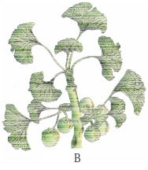
Q.19 Identify the plants shown in figure and select the correct option.
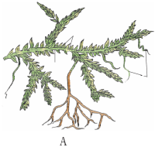

A B
(1) Sphagnum Dictyota
(2) Selaginella Ginkgo
(3) Selaginella Salvinia
(4) Cycas Ginkgo

Q.20 Identify the given figures of algae
and select the correct option.
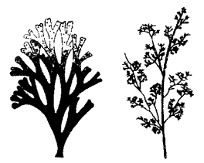

A B
(1) Fucus Polysiphonia
(2) Dictyota Polysiphonia
(3) Dictyota Porphyra
(4) Porphyra Polysiphonia

Q.21 Holdfast, stipe and frond constitutes the plant body in case of –
(1) Rhodophyceae (2) Chlorophyceae
(3) Phaeophyceae (4) All of the above

Q.22 Which of the following options correctly identifies the plant shown in figure and the group it belongs to?
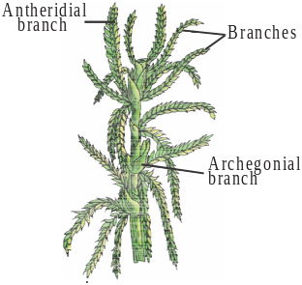

(1) Selaginella – Pteridophyte
(2) Sphagnum – Moss
(3) Sphagnum – Liverwort
(4) Funaria – Moss

Q.23 Select the incorrect statement regarding reproduction in Rhodophyceae.
(1) Asexual reproduction occurs by non-motile spores.
(2) Sexual reproduction occurs by motile gametes.
(3) Sexual reproduction is oogamous.
(4) Complex post-fertilization developmental events occur.

Q.24 Read the given statements about algae and select the correct option.
(i) Plant body is thalloid.
(ii) Largely aquatic.
(iii) Reproduction by vegetative, asexual & sexual methods.
(iv) Chlamydomonas, Volvox, Ulothrix are the multicellular algae.
(1) Statements (i) and (ii) are true
(2) Statements (ii) and (iii) are true
(3) Statements (i), (ii) and (iii) are true
(4) All statements are true

Q.25 ln double fertilization, one male gamete fuses with the __(i)_ to form zygote and the other male gamete fuses with __(ii)__ to form primary endosperm nucleus.
(1) synergids (n), antipodals (n)
(2) egg (n), antipodals
(3) egg (n), secondary nucleus (2n)
(4) egg (n), synergids (n)

Q.26 _______ do not have free living gametophyte.
(1) Bryophytes (2) Pteridophytes
(3) Gymnosperms (4) both (2) and (3)

Q.27 The giant Redwood tree (Sequoia sempervirens) is a/an
(1) Angiosperm (2) Free fern
(3) Pteridophyte (4) Gymnosperm

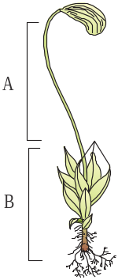
Q.28 Select the option that correctly identifies A and B in the given figure.

A B
(1) Sporophyte Gametophyte
(2) Gametophyte Sporophyte
(3) Male shoot Female shoot
(4) Female shoot Male shoot

Q.29 Coralloid roots of __ have symbiotic association with
N2 - fixing cyanobacteria.
(1) Pinus (2) Cedrus
(3) Cycas (4) Ginkgo

Q.30 A plant shows thallus level of organization. It shows rhizoids and is haploid. It needs water to complete its life cycle because the male gametes are motile. Identify the group to which it belongs to –
(1) Pteridophytes (2) Gymnosperms
(3) Monocots (4) Bryophytes

Q.31 In pteridophytes, prothallus produces –
(1) sporangia
(2) antheridia and archegonia
(3) vascular tissues
(4) root, stem and leaf.

Q.32 Artificial systems gave equal weightage to vegetative and sexual characteristics; this is not acceptable because often _____ characters are more easily affected by environment.
(1) vegetative (2) sexual
(3) anatomical (4) physiological

Q.33 Major photosynthetic pigments in green algae are
(1) Chlorophyll a and b
(2) Chlorophyll a, c and fucoxanthin
(3) Chlorophyll a, d and phycoerythrin
(4) Chlorophyll a and c.

Q.34 A Prothallus is
(1) A structure in pteridophytes formed before the thallus develops.
(2) A sporophytic free living structure formed in pteridophytes.
(3) A gametophyte free living structure formed in pteridophytes.
(4) A primitive structure formed after fertilization in pteridophytes.

Q.35 The given figure shows two phases, A and B of a typical angiospermic life cycle. Select the correct option regarding it.
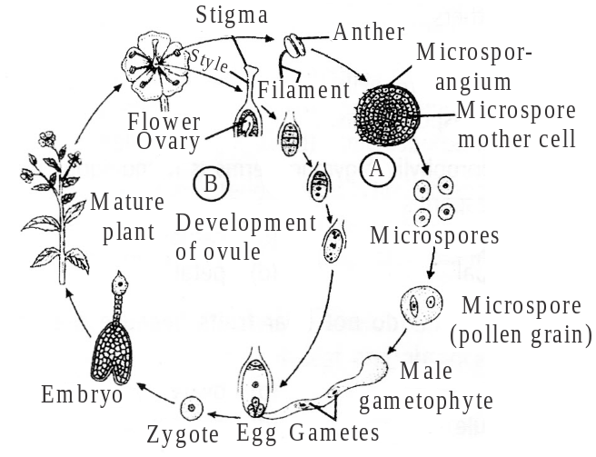

(1) A-Gametophytic generation (n)
B-Sporophytic generation (2n)
(2) A-Sporophytic generation (2n)
B-Gametophytic generation (n)
(3) A-Sporophytic generation (2n)
B-Sporophytic generation (2n)
(4) A-Gametophytic generation (n)
B-Gametophytic generation (n)

Q.36 Match Column-I with Column-II and select the correct option from the codes given below.
Column-I Column-II
A. Food (i) Brown algae
B. Agar (ii) Porphyra, Laminaria
C. Algin (iii) Gelidium, Gracilaria
D. Carrageenin (iv) Red algae
(1) A-(ii), B-(iii), C-(i), D-(iv) (2) A-(ii), B-(iii), C-(iv), D-(i)
(3) A-(iii), B-(ii), C-(iv), D-(i) (4) A-(iii), B-(ii), C-(i), D-(iv)

Q.37 Common example of red algae is
(1) Porphyra (2) Gracilaria
(3) Ectocarpus (4) both (1) and (2)

Q.38 In pteridophytes, main plant body is a (i) which is (ii) into true roots, stem and leaves.
Fill the blanks in above statement and select the correct option.
(1) (i)-Sporophyte, (ii)-differentiated
(2) (i)-Sporophyte, (ii)-not differentiated
(3) (i)-Gametophyte, (ii)-differentiated
(4) (i)-Gametophyte, (ii)-not differentiated

Q.39 The leaves of gymnosperms are well-adapted to withstand extremes of temperature, humidity and wind, because of which of the following features?
(1) Needle like leaves (2) Thick cuticle
(3) Sunken stomata (4) All of these
Q.40 In gymnosperms the development of pollen grains take place with in the
(1) megasporangia (2) microsporangia
(3) male gametophyte (4) female gametophyte

Q.41 Spirogyra, Volvox and Chlamydomonas shows
(1) haplontic life cycle
(2) diplontic life cycle
(3) haplo-diplontic life cycle
(4) diplobiontic life cycle

Q.42 In gymnosperms ovules are borne on
(1) microsporophyll (2) megasporophyll
(3) macrosporophyll (4) Both (1) and (3)

Q.43 In angiospermic fertilisation, one male gamete fuses with egg to form __A__, this event is called __B__
Identify A and B and choose the correct option.
(1) A-endosperm; B-syngamy
(2) A-zygote; B-syngamy
(3) A-embryo; B-triple fusion
(4) A-endosperm; B-triple fusion

Q.44 In angiosperms embryo sac consists of
(1) one egg cell
(2) two synergids
(3) three antipodal and two polar nuclei
(4) All of the above

Q.45 The cones bearing megasporophyll with ovules are called
(1) male strobili (2) female strobili
(3) megasporangia (4) microsporangia

Biology CDP B3.1 Solutions Mr. Nazim Husain

Botany NEET I CUET Topic: Plant Kingdom Biology Expert

Biology Topic : Plant Kingdom [SOLUTIONS]

(1) (2) (2) (1) (3) (4) (4) (3)
(5) (4) (6) (3) (7) (2) (8) (4)
(9) (2) (10) (1) (11) (4)
(12) (3). Anisogamy is fusion of two motile gametes dissimilar in size. It is observed in some species of Chlamydomonas. Oogamy is also fusion of two dissimilar sized gametes in which female gamete is larger but non-motile. Isogamy is fusion of two similar sized motile gametes.
(13) (3). Heterospory is the production of spores of two different sizes and of two different developmental patterns - smaller male or microspores and larger female or megaspores. Heterospory is the most important evolutionary development in the vascular plants because it has ultimately led to seed development e.g. Selaginella, Salvinia, Azolla, etc.
(14) (4). Haplo-diplontic type of life cycle involves the clear alternation of generations between a haploid gamete producing gametophyte and a diploid spore producing sporophyte. Both bryophytes and pteridophytes exhibit this kind of life cycle pattern. In bryophytes, a dominant, independent, photosynthetic, thalloid or erect phase is represented by a haploid gametophyte and it alternates with the short-lived multicellular sporophyte totally or partially dependent on the gametophyte for its anchorage and nutrition. In pteridophytes, the diploid sporophyte is represented by a dominant, independent, photosynthetic, vascular plant body. It alternates with multicellular, saprophytic autotrophic, independent but short-lived haploid gametophyte. While most algal genera are haplontic, some of them such as Ectocarpus, Polysiphonia, kelps are haplo-diplontic.
(15) (3). The sex organs in bryophytes (Riccia, Funaria), pteridophytes & gymnosperm (Cycas) are multicellular and jacketed. The jacket of sterile cell around the sperm and egg is an adaptation to a life on land. The male reproductive organs are antheridia and female reproductive organs are archegonia.
(16) (3).
(17) (2). In Marchantia, the plant body consists of a dorsiventrally flattened, prostrate and dichotomously branched thallus. The thalli are conspicuous, apex of each thallus is notched. Along the mid-rib are present characteristic, prominent goblet or cup-shaped structures, the gemma cups, with smooth, dentate or frilled margins. These cups enclose asexual reproductive bodies called gemma.
(18) (3). Chemotaxonomy is based upon the characteristics of various chemical constituents of organisms. Chemical constituents of plant species have been found to be unvarying and do not change easily. Chemical characters have also helped in establishing relationships and statistical evaluation of taxonomic information.
(19) (2). Plants given in the figure are A - Selaginella and B- Ginkgo respectively. Selaginella is a trailing, hanging or erect evergreen lycopod (Pteridophyte).
Ginkgo biloba (a Gymnosperm) has not changed for the last several millions of years since its appearance in triassic period. It is also called living fossil. The plant has survived due to interest shown by horticulturists. It has natural immunity to several plant diseases.
(20) (2). Dictyota is a ribbon shaped dichotomously branched marine brown alga that grows in shallow waters. Its frond is flat and dichotomously branched. Polysiphonia is a small, upright, bushy marine red alga, fixed to the substratum by rhizoids, hold fast, etc.
(21) (3). Phaeophyceae (Brown algae) are eukaryotic marine algae. The body consists of branched filamentous structure in lower forms (e.g. Ectocarpus) and parenchymatous structure in higher forms (e.g. Sargassum). The plant body is often differentiated into holdfast, stipe and lamina (frond). Lamina may be simple or divided variously and is photosynthetic.
(22) (2). Plant shown in the figure is Sphagnum. It is a bryophyte, commonly called as peat moss. It often grows in acidic marshes.It is hygroscopic and possesses a remarkable water holding capacity. Hence, it is used as a packing material in transportation of flowers. It is also used in seedbeds and in moss sticks.
(23) (2). Sexual reproduction is oogamous. The male sex organ is called spermatangium or antheridium. It produces nonflagellate male gamete known as spermatium. The female sex organ is flask-shaped and is termed carpogonium. Carpogonium possesses an elongated receptive organ named trichogyne. Spermatia are carried by water current to trichogyne tips for effective fertilization. The female sex organ remains attached to the plant & forms a new structure called carposporophyte.
(24) (3). Algae are usually aquatic, either marine or fresh water. Only a few algae occur in moist terrestrial habitats like tree trunks, wet rocks, moist soil, etc. Plant body is thallus (a form without any differentiation into root, stem and leaves) which may be unicellular, colonial, filamentous, parenchymatous or pseudoparen-chymatous. Sexual, asexual and vegetative modes of reproduction are abundant. Form and size of algae range from microscopic unicellular forms like Chlamydomonas, to colonial forms like Volvox and to filamentous forms like Ulothrix and Spirogyra.
(25) (3). Double fertilization is a process unique to flowering plants in which two male gamete nuclei, which have travelled down in the pollen tube separately fuse with different female nuclei in the embryo sac. The first male nucleus fuses with egg cell to form the zygote, the second male nucleus fuses with the two polar nuclei or secondary nucleus to form a triploid nucleus that develops into the endosperm.
(26) (3). In Gymnosperms, the male and female gametophytes do not have an independent free living existence. They remain within the sporangia retained on the sporophytes i.e., female gametophyte within megasporangium and male gametophyte within microsporangium. In Pteridophytes, the gametophyte is although small and inconspicuous, but is usually independent.
(27) (4). Sequoia sempervirens is a gymnosperm. It is the sole living species of genus Sequoia. Its common names include coast red wood, California red wood. It is an evergreen, long living monoecious tree.
(28) (1). Funaria exhibits gametophytic (n) as well as sporophytic (2n) generation in its life cycle. The gametophytic generation is represented by a short lived protonema which produces spermatozoids in antheridium of male shoot and egg in archegonium of female shoot. Sporophyte of Funaria has embedded foot, an elongated curved seta and a terminal pyriform capsule. Sporophyte is nutritionally dependent on gametophyte.
(29) (3). The coralloid roots of Cycas are symbiotically associated with nitrogen fixing blue-green algae, Anabaena cycadae and Nostoc punctiforme. In the middle cortex of coralloid roots, there occurs a broad blue green zone, which is known as algal zone. Coralloid roots are irregular, negatively geotropic, dichotomously branched coral likes roots which do not possess root hair and root caps.
(30) (4). Bryophytes are nonvascular terrestrial plants of moist habitat in which a multicellular diploid sporophyte lives as a parasite on an independent multicellular haploid gametophyte that develops multicellular jacketed sex organs. True roots are absent, instead rhizoids occur, which may be unicellular or multicellular. An external layer of water is essential for the swimming of male gametes to the archegonia.
(31) (2). The gametophytes bear male and female sex organs called antheridia and archegonia, respectively.
(32) (1).
(33) (1). Classes of algae and their main characteristics have been summarised in the table given below:
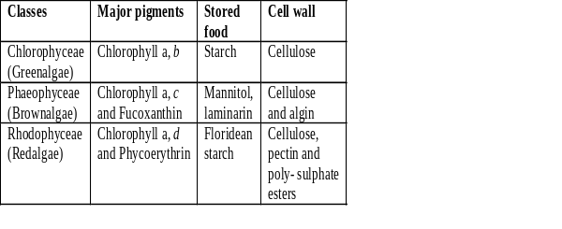
(34) (3). Prothallus is a small flattened multicellular structure that represents the independent gametophyte generation in pteridophytes, e.g., club mosses, horsetails and ferns. In some of the pteridophytes a single prothallus bears both male and female sex organs. In others there are separate male and female prothalli.

(35) (1).
(36) (1).
(37) (4). Porphyra and Gracilaria, both are red algae (Rhodophyceae). Ectocarpus is a filamentous marine brown alga (Phaeophyceae).
(38) (1).
(39) (4). Conifers have a number of xerophytic characters such as needle-like (e.g., Pinus), scale-like (e.g., Thuja) or small and leathery leaves (e.g., Araucarias), thick cuticle, sclerenchymatous hypodermis and sunken stomata to reduce transpiration. They are, thus, well adapted to tide over the winter period when the soil becomes frozen and availability of water is very little.
(40) (2). In gymnosperms the development of pollen grains take place with in the microsporangia.
(41) (1). Haplontic life cycle is primitive type of life cycle. Haplontic life cycle is followed by algae such as Spirogyra, Volvox and Chlamydomonas.
(42) (2). The ovules are borne on megasporophylls which may be clustered to form the female cones.
(43) (2). A-zygote; B-syngamy
In angiospermic sexual reproduction, syngamy is the nuclear fusion of one male gamete with the egg producing diploid zygote or oospore.
(44) (4). An ideal embryo sac contains 7-cells and 8-nuclei. 3 cells are present at the micropylar end and form egg apparatus, mid of which forms egg cell and rest two lateral form synergids. One cell present in the centre of embryo sac, known as central cell and contains two nuclei and rest three cells are present at chalazal end for antipodal cells.
(45) (2). The cones bearing megasporophyll with ovules are called female strobili or megasporangia or macrosporangiate. Both megasporophyll and microsporophyll may be present on same plant (e.g., Pinus) or may be present separately.

